

Rochester Institute of Technology
Information & Technology Services
RIT RSS User Manual

Proprietary Information

This document contains proprietary information and is not for use outside Rochester Institute of Technology. Information within this document is subject to change without notice.

Document Change Control

Revision | Date | Author | Section | Content Changes or Additions
v.1 | 4/20/03 | Carol Coon | All | Document Outline
v.2 | 5/6/03 | Carol Coon | All | Added Content
Content Owner

Name | Department | Phone Number | Alternate Contact
Kristi Davis | ITS | 475-2800  Kristi@Rit.edu | Jeremy Trumble (jltisd@rit.edu)

Table of Contents
1 Introduction 5
1.1 Purpose 5
1.2 Background 5
1.3 Getting Started 5
1.4 How to Make Images Accessible to an RSS News Feed 5
2 General User Actions 5
2.1 Login 5
2.2 Logout 6
2.3 Main Menu 6
3 Content Owner Actions 7
3.1 Create a News Item 7
3.1.1 “Create News Item” 7
3.1.2 “Choose Template” 9
3.1.3 “Preview News Item” 9
3.2 Remove a News Item 9
3.2.1 “Select News Feed” 9
3.2.2 “Choose News Item” 10
3.3 Add Existing Webpage As News Item 10
3.3.1 “Link a Previously Written News Item” 10
4 Administrator Actions 12
4.1 Add Content Owners 12
4.1.1 “Add Content Owner” 12
4.1.2 “Add Content Owner” - Details 12
4.2 Remove Content Owners 13
4.2.1 “Select Department” 13
4.2.2 “Remove Content Owners” 14
4.3 Regenerate News Feed 14
4.3.1 “Select Department” 14
4.4 Modify News Feed Name 14
4.4.1 “Select News Feed” 14
4.4.2 “Modify Feed Name” 14
Appendix A – Definitions and Abbreviations 15
Appendix B – HTML Tutorial 17
B.1 HTML Tags 17
B.2 HTML Generating Applications 18
Appendix C – FTP Tutorial 19
C.1 WS-FTP 19
C.2 Command Line FTP 19

Table of Figures
Figure 1 Login Page 6
Figure 2 Main Menu 7
Figure 3 Create News Item Page 8
Figure 4 Link a Previously Written News Item Page 11
Figure 5 Add Content Owner Detail Page 13
Figure 6 Command Line FTP 20

Table 1 Definitions 15
Table 2 HTML Quick Reference 17

Introduction

Purpose
The purpose of this document is to guide a user through the RSS News Generator (RNG). This document will take the user from login to logout and all the actions in between.

Background
The RIT ITS department manages the structure of the myRIT web portal. The myRIT web portal contains news portlets that are built from standard RSS feeds. Individual departments at RIT are responsible for providing content of the news portlets in the form of news items. Many departments lack the technical capabilities to do this. The use of this tool will provide departments with the capabilities to generate and manage the content of their news portlet.

Getting Started
In order to use RNG you must have a DCE account. If you do not have a DCE account, you will need to contact ITS to get one. You will also have to have access to RNG. If you have not been added to the RNG system, you will also need to contact ITS.

How to Make Images Accessible to an RSS News Feed
In order for images to be put in your department’s news feed, the image must be deposited in an appropriate location within your department’s grace account. A file transfer tool is the most common means of transferring documents to a remote location.

A common software application for file transfer is WS-FTP. For a complete guide to installing and using WS-FTP, download the ITS ftp tutorial. Or for alternate FTP methods, see Appendix C – FTP Tutorial.

General User Actions

Login
To login, enter your DCE username and password into the appropriate text boxes. Click Submit, or press “Enter” and you will be taken to the Main Menu. See Figure 1.

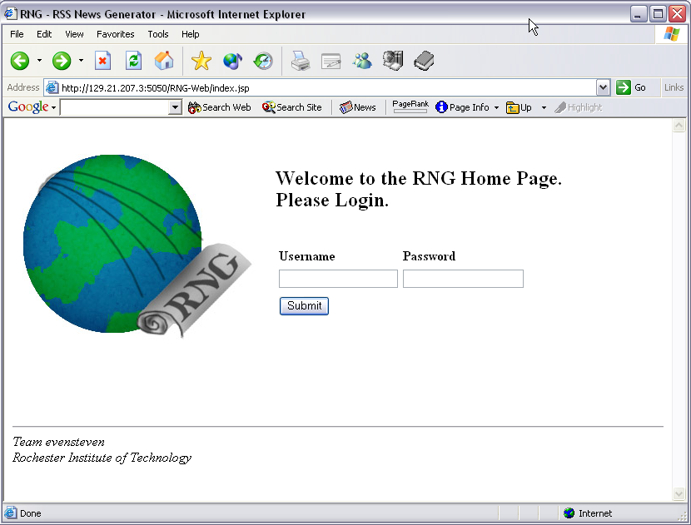
Figure 1 Login Page

Logout
In the upper right hand of every page but the login page is a logout button. You can see this in Figure 2. Clicking on the button will end your session and return you to the login page. Entering any URL other than the login page’s URL when you are not logged in will automatically send you to the login page to force a login.

Main Menu
All users, content owners and administrators, can see the Main Menu. If you are a content owner you will only see links for content owner functionality. If you are an administrator, then only administrative functionality links will be available. See Figure 2.

As a content owner, you are only allowed to access the news feeds to which you have content owner permissions. As an administrator, you are only allowed to administrate the feeds to which you have permission.

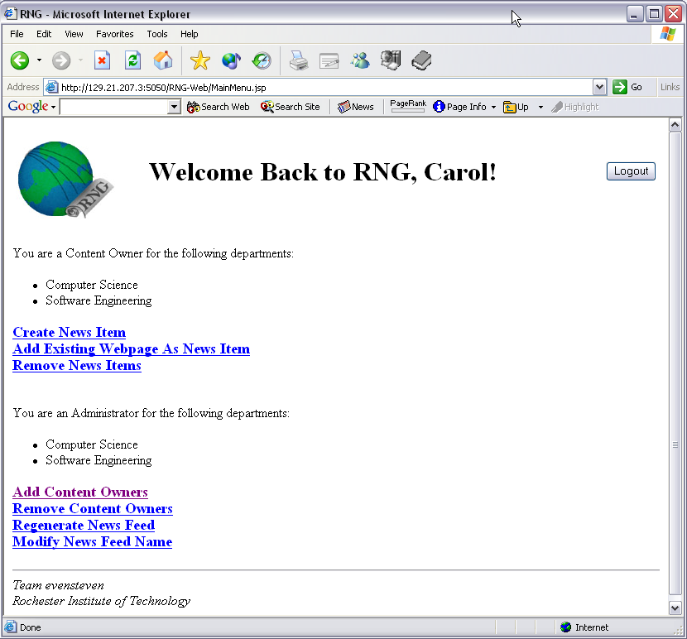
Figure 2 Main Menu

Content Owner Actions

Create a News Item

“Create News Item”
Clicking on the “Create News Item” link will take you to a page entitled “Create News Item.” This is the page where all the information for the news item is to be entered. The only required fields are “Title of News,” “News,” and “News Feed.”

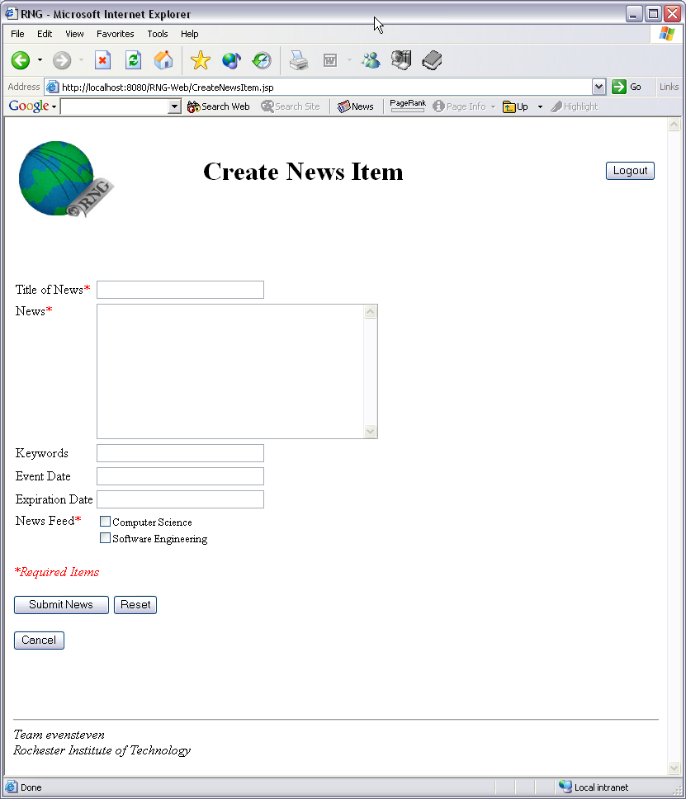
Figure 3 Create News Item Page

- Title of News
The title of your news item. It can contain any characters (A-Z, a-z), any special characters (!, @, #, $, %, etc.), and any numbers. The title must be less than 50 characters.
- News
This is where the content of your news item goes. It can contain any characters (A-Z, a-z), any special characters (!, @, #, $, %, etc.), all white space (carriage return, tabs and spaces), and any numbers. The news content can be any length. The news item can also contain HTML tags (See Appendix B – HTML Tutorial).
- Keywords
Significant or descriptive words that would reference your article when used in a search. Search is not supported in the release.
- Event Date
The date the event takes place.
- Expiration Date
The date that the news item will no longer be valid or when the news item should be deleted.
- News Feed
Check the box(es) that the news item should be posted.

Clicking on the “Submit News” button will take you to the “Choose Template” page. Clicking on the “Reset” button will clear all the text boxes. Clicking on “Cancel” will return you to the main menu.

“Choose Template”
Select the radial button next to the template you wish to choose and click “SUBMIT” to continue to the Preview page. Clicking “Change News Item” will return you to the “Change News Item” page. Clicking “Cancel” will return you to the main menu.

“Preview News Item”
The preview of your news item will be displayed. If you click “Save News Item” the news item will be saved and you will be returned to the main menu and a message will appear under the title of the page verifying that the news item was saved. Clicking “Change News Item” will return you to the “Create News Item” page. Clicking “Change Template” will return you to the “Choose Template” page. Clicking “Cancel” will return you to the main menu without saving.

Remove a News Item

“Select News Feed”
Clicking on “Remove News Items” link will take you to the “Select News Feed Page”. On this page you must select the news feed that you want to delete news items from. You will only be allowed to select one news feed at a time. Clicking “SUBMIT” will continue you to the “Choose News Item” page. Clicking “Main Menu” will cancel the action and return you to the main menu.

“Choose News Item”
Check all the news items that you wish to remove. Clicking “Check All” will check all the boxes. Clicking “Uncheck All” will uncheck all the boxes. Clicking “SUBMIT” will remove the news item(s) from the feed and return you to the main menu with a message below the title stating that the news item(s) have been removed. Clicking “Main Menu” will cancel the action and return you to the main menu.

Add Existing Webpage As News Item

“Link a Previously Written News Item”
Clicking on the “Add Existing Webpage As News Item” link will take you to a page entitled “Link Previously Written News Item.” This is the page where all the information for the news item is to be entered. The only required fields are “Title,” “Location,” which is a URL, and “News Feed.”

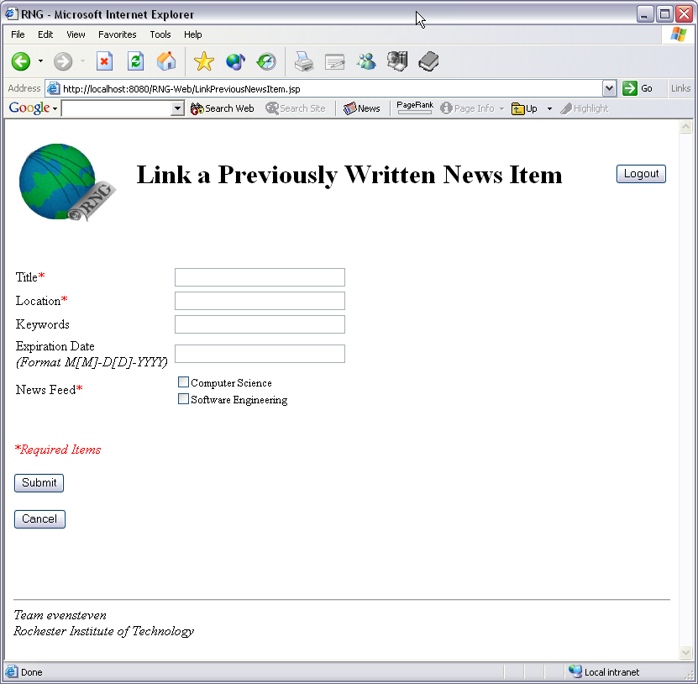
Figure 4 Link a Previously Written News Item Page
- Title
The title of your news item. It can contain any characters (A-Z, a-z), any special characters (!, @, #, $, %, etc.), and any numbers. The title must be less than 50 characters.
- Location
This is the location of the news feed. RNG will create a link to this location.
- Keywords
Significant or descriptive words that would reference your article when used in a search.
- Expiration Date
The date that the news item will no longer be valid or when the news item should be deleted.
- News Feed
Check the box(es) that the news item should be posted.

Clicking on the “Submit” button will save the link and return you to the main menu where a message will be displayed under the title stating that the link was saved successfully. Clicking on the “Cancel” button will return you to the main menu without saving a link.

Administrator Actions

Add Content Owners

“Add Content Owner”
Clicking on “Add Content Owners” link will take you to the “Add Content Owner” page. On this page you must select the department you want to add a content owner to. You will only be allowed to select one department at a time. Clicking “SUBMIT” will continue you to the “Add Content Owner” page. Clicking “Main Menu” will cancel the action and return you to the main menu.

“Add Content Owner” - Details
This is the page where all the information for the content owner is to be entered. The required fields are “Name,” and “Username.”

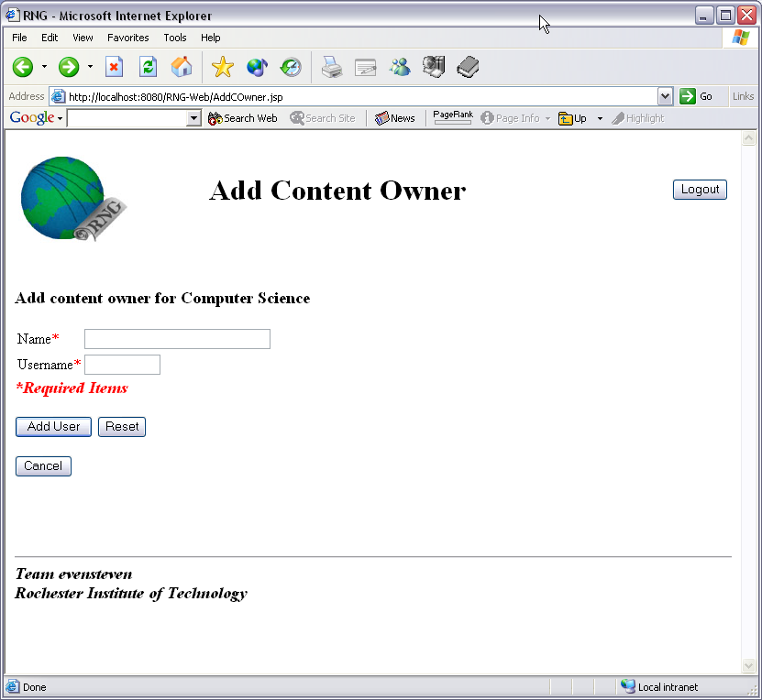
Figure 5 Add Content Owner Detail Page
- Name
This is for the person’s full name.
- Username
This is the person’s DCE username.

Remove Content Owners

“Select Department”
Clicking on the “Remove Content Owners” link will take you to the “Select Department” page. On this page you must select the news feed that you want to delete a content owner from. You will only be allowed to select one news feed at a time. Clicking “SUBMIT” will continue you to the “Remove Content Owners” page. Clicking “Main Menu” will cancel the action and return you to the main menu.

“Remove Content Owners”
Check all the content owners that you wish to remove. Clicking “Check All” will check all the boxes. Clicking “Uncheck All” will uncheck all the boxes. Clicking “SUBMIT” will remove the content owner(s) from the feed and return you to the main menu with a message below the title stating that the content owner(s) have been removed. Clicking “Main Menu” will cancel the action and return you to the main menu.

Regenerate News Feed

“Select Department”
Clicking on the “Regenerate News Feed” link will take you to the “Select News Feed” page. On this page you must select the news feed that you want to regenerate. You will only be allowed to select one news feed at a time. Clicking “SUBMIT” will regenerate the feed and return you to the main menu with a message below the title stating the feed has been properly regenerated. Clicking “Main Menu” will cancel the action and return you to the main menu.

Modify News Feed Name

“Select News Feed”
Clicking on the “Modify News Feed Name” link will take you to the “Select News Feed” page. On this page you must select the news feed whose name you wish to change. You will only be allowed to select one news feed at a time. Clicking “SUBMIT” will continue you to the “Modify Feed Name” page. Clicking “Main Menu” will cancel the action and return you to the main menu.

“Modify Feed Name”
This page is where you change the name of the feed. Edit the news feed name in the text box next to “News Feed Title.” Clicking “SUBMIT” will change the news feed name and return you to the main menu with a message below the title stating that the news feed name has been changed. Clicking “Main Menu” will cancel the action and return you to the main menu.

Appendix A – Definitions and Abbreviations

Table 1 Definitions
Browser | A program such as Mosaic, Netscape, Internet Explorer, Lynx, and others that are used to view pages on the World Wide Web
Content Owner | An authorized employee of a department who creates and manages news items
Department Administrator | An authorized user from RIT department who will maintain the RSS News Feed for his/her department. This person also maintains the user list of RNG for his/her department
FTP | File Transfer Protocol. The protocol used on the Internet for sending files
HTML | Short for Hyper Text Markup Language, the authoring language used to create documents on the World Wide Web
HTTP | Short for Hyper Text Transfer Protocol, the underlying protocol used by the World Wide Web. HTTP defines how messages are formatted and transmitted, and what actions Web servers and browsers should take in response to various commands
ITS | A department that provides information and technology services to RIT to achieve its goals
Link | A string that will connect to the physical location of news items
LDAP | Short for Lightweight Directory Access Protocol, a set of protocols for accessing information directories
News | An HTML document containing news from RIT departments to students
News Writer | An editor component, that lets the user creates different categories of news items such as party invitations, lecture announcement, open house in variety of formats
Portlet | A section of a portal that is allocated for items in an RSS News feed
Prometheus | The portal application
Protocol | An agreed upon format for transmitting data between two devices
RNG | RSS News Generator. Name of the system
RSS | Short for RDF Site Summary or Rich Site Summary, an XML format for web content. A web site that wants to allow other sites to publish some of its contents creates an RSS document and registers the document with RSS publisher
RSS Generator | An application that creates/updates RSS document from an existing HTML document
RSS News Feed | RSS document containing links to html news items
RSS Updater | A component that updates the RSS News Feed
Super User | An authorized employee of ITS, who maintains the users groups of RNG
Uploader | A component that lets the user upload news items on web server
URL | An abbreviation of uniform resource locator, the global address of documents and resources on the web
Use Case | An interaction between user and the system, accomplishing a task
Web Portal | A website or services that offers a broad array of resources and services, such as news, forums and search engines
Web Server | A computer that provides World Wide Web services in the internet
World Wide Web | A collection of websites linked together

Appendix B – HTML Tutorial

B.1 HTML Tags
If you are creating your news item using the RNG Tool, you will notice that there is no formatting outside the automatic formatting by choosing a template. It is possible to use HTML tags to do formatting. An HTML tag has a beginning tag and a closing tag. These two tags enclose the text that you wish to change. Below is a quick reference of the tags that you can use and what they do. Note that tags CANNOT span two lines in this application. Also case and white space inside tags (<…>) do not matter.

Table 2 HTML Quick Reference
Tag | Description
<a href=”…”>…</a> | Link ex. <a href=”http://www.rit.edu”>Rochester Institute of Technology</a>
<h1>… </h1> | Most Prominent Header – big and bold
<h2>…</h2> | Header
<h3>…</h3> | Header
<h4>…</h4> | Header
<h5>…</h5> | Least Prominent Header
<b>…</b> | Bold Face
<i>…</i> | Italics
<u>…</u> | Underline
<tt>…<tt> | Typewriter font
<em>…</em> | Emphasis
<strong>…</strong> | Stronger Emphasis
<code>…</code> | Displays in terminal font
<dl>  <dt>  <dd>  <dt>  <dd>  …  </dl> | Start the list  First term to be defined  Definition of first term  Second term to be defined  Definition of second term  Can continue <dt>,<dd> pairs  Finish the list
<ul>  <li>  <li>  …  </ul> | Start an Unordered list (like a bulleted list)  First List Item  Second List Item  Can continue <li>  End Unordered list
<ol>  <li>  <li>  …  </ol> | Start an Ordered list (like a numbered list)  First List Item  Second List Item  Can continue <li>  End Ordered list

B.2 HTML Generating Applications
Microsoft Word will easily allow you to create web pages. Write your document as you would any document and Word will allow you to save it as a web page. Click “File” and select “Save as Web Page…”

You can also begin with a web page. Click the “Start” button, and select “New Office Document” and choose Web Page. Create the page as you would any Word Document and save it as described above.

Appendix C – FTP Tutorial

FTP stands for File Transfer Protocol. It is the protocol used on the Internet to transfer files. A protocol is an agreement between two computers as to what format is to be used to transfer data.

C.1 WS-FTP

If you have an existing news item that you created using Word, FrontPage or other HTML generating applications, and you wish to create a link to this document, you must first move the document to an appropriate location in your department’s grace account. As stated above, you may use WS-FTP to transfer your file. You can download the ITS WS-FTP Tutorial.

C.2 Command Line FTP

If you don’t want to bother with downloading a tool and learning how to use it, the following tutorial will show you a quick and easy way to FTP a file without having to download an application.

Windows
- Click on the “Start” Button
- Click on “Programs”
- Click on “Accessories”
- Click on “Command Prompt”
- This will open a Command Prompt
- Navigate to the folder where the news item is on your computer
  - Typing “dir” will list all the files and folders in the folder you are currently in
    - The last column is the name of the file or folder
    - If “<DIR>” is in the third column, then it is a folder (directory)
  - Typing “cd” a space and the name of a folder will take you into that folder
  - Typing “cd ..” (Two Periods) will take you to the folder one level above the folder you are currently in
- Once you are in the directory you want, type “ftp grace.rit.edu”
- Enter your DCE username at the prompt (or the departmental username)
- Hit “Enter”
- Enter your DCE password at the password prompt (or the departmental password)
- Hit “Enter” to log in to grace
Hint: Typing “help” and hitting “enter” will give you the list of available commands
Hint: Typing “help”, a space and the name of the command and hitting “enter” will tell you what the command does
Hint: Typing “lcd” and hitting “enter” will list the files on your computer
Hint: Typing “cd” and hitting “enter” will list the files in the folder on grace
- Navigate to the appropriate grace folder the same way you did above (see step 6)
- Type “put”, a space and the name of the file you want to transfer to the grace account and hit “enter”
- The file has been transferred.
- Type “bye” and hit “enter” to quit FTP
- Type “exit” and hit “enter to quit the command prompt or click on the “X” in the upper right corner

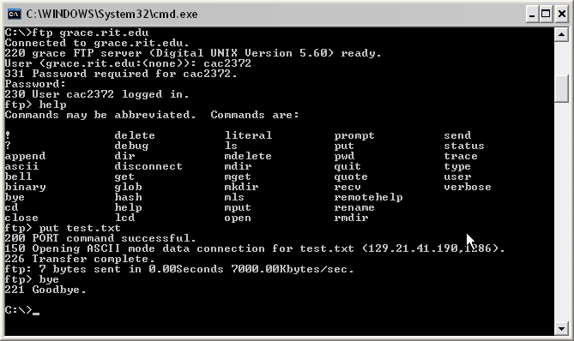
Figure 6 Command Line FTP

